
Department | FED
Subject | DSA-2
Academic Year | I-III Semester (2025-26)
Faculty Name | Dr. Mohammed Razia Alangir Banu
Student Name | Rayanki Himavarshini
Roll Number | 2520080038
Branch | AI & DS
Course Outcome | CO1

Case Study Topic: AgroChain – Smart Agriculture Supply Chain Management System.
Work Done Summary:
In this case study, we implemented an AVL Tree for managing agricultural products in the AgroChain Smart Agriculture Supply Chain Management System.
The AVL Tree stores product IDs in a balanced binary search tree structure, enabling fast insertion, deletion, and searching operations. We inserted multiple product records into the AVL Tree and observed balancing operations such as LL, RR, LR, and RL rotations whenever the balance factor exceeded the allowed limit.
The implementation was developed in Java to efficiently organize agricultural product information and improve retrieval performance.

Implementation Details:
• Created an AVL Tree data structure to store agricultural product IDs.

• Inserted product records into the AVL Tree in different orders.

• Calculated the balance factor for each node after every insertion.

• Performed LL (Left-Left) rotations when the tree became left-heavy.

• Performed RR (Right-Right) rotations when the tree became right-heavy.

• Applied LR (Left-Right) and RL (Right-Left) rotations when required to maintain balance.
• Implemented search functionality to quickly locate a specific product ID.

• Used in-order traversal to display product records in sorted order.

• Verified that the AVL Tree remained balanced after all insertions.

Input Screenshot :
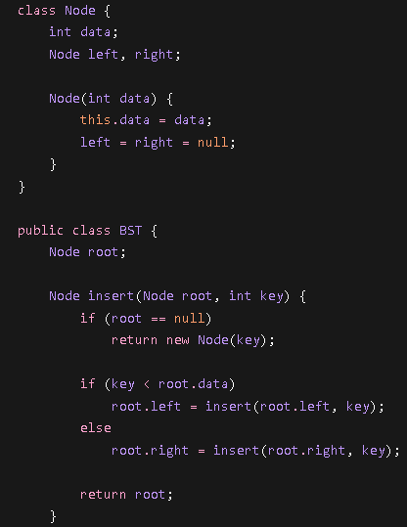
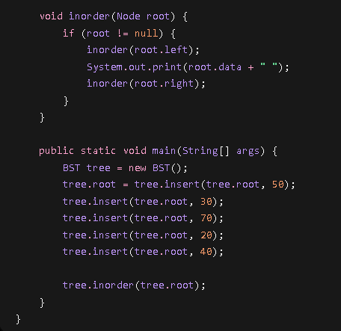

Output Screenshot :
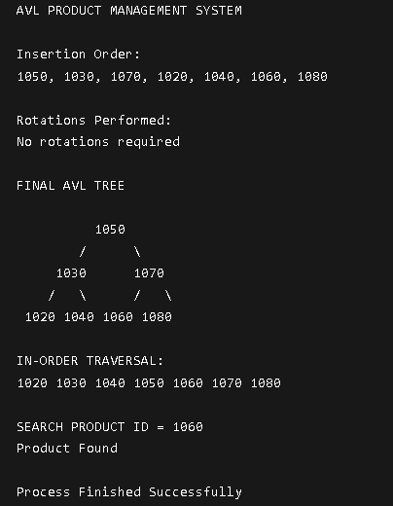
Result :
The AVL Tree successfully stored and managed agricultural product records while maintaining a balanced structure. Product IDs were displayed in sorted order using in-order traversal. Search operations were completed efficiently, and balancing rotations ensured optimal tree height. The implementation demonstrated that AVL Trees provide faster search, insertion, and deletion operations compared to an unbalanced Binary Search Tree.
Time Complexity:
- Insert: O(log n)
- Search: O(log n)
- Delete: O(log n)
Space Complexity:
- O(n)

GITHUB LINK : https://github.com/Himavarshini-07/AgroChain-Smart-Agriculture-Supply-Chain-Management-System

Student Signature | Faculty Signature

